

**BIG MARKET SALES PREDICTION**

DATA MINING (SWE2009) project report

**Submitted to:**

**Pattabiraman V**

**Submitted by:**

BHUVANESHWARI K (19MIS1196)

DEEPIKA G (19MIS1159)

GURU PRASHATH M (19MIS1122)

**TABLE OF CONTENTS**

**Page No**

1. Abstract.................................................................................................................................3

2. Introduction............................................................................................................................4

3. Feasibility study.....................................................................................................................4

4. Design and flow of models....................................................................................................5

5. Risk Analysis.........................................................................................................................5

6. Information of Dataset...........................................................................................................6

7. Implementation...............................................................…………………………………...7

7.1 Pre-Processing Data...............................................................................……................7

7.2 Data Visualization...................................................................……………………...13

7.3 Data Analysis...................................………………………………………………..20

7.4 Comparing Models................................…………………………………………….27

7.5 UI Design…………………………………………………………………………34

8. Result...................................................................................................................................42

9. Conclusion..........................................…………………………………………………….43

10. References.........................................................................................................................43

1. **ABSTRACT:**

Now a-days shopping malls and big marts keep the track of their sales data of each and every individual item for predicting future demand of the customer and update the inventory management as well. These data stores basically contain a large number of customer data and individual item attributes in a data warehouse. Sales forecasting is an important aspect of different companies engaged in retailing, logistics, manufacturing, marketing and wholesaling. Most of the business organizations heavily depend on a knowledge base and demand prediction of sales trends. The accuracy in sales forecast provides a big impact in business. It allows companies to efficiently allocate resources, to estimate achievable sales revenue and to plan a better strategy for future growth of the company. As we know traditional forecast systems are difficult to deal with big data and accuracy of sales forecasting. So, in our project, we briefly analyze the concept of sales data and sales forecast using machine learning algorithms. The results are summarized in terms of reliability and accuracy of efficient techniques taken for prediction and forecasting. Prediction of sales of a product from a particular outlet is performed via a two-level approach that produces better predictive performance compared to any of the popular single model predictive learning algorithms. It allows companies to efficiently allocate resources, to estimate achievable sales revenue and to plan a better strategy for future growth of the company.

1. **INTRODUCTION:**

Day by day the competition among shopping malls as well as big marts is getting more serious and aggressive only due to the rapid growth of the global malls and on-line shopping. Establishment of a business is not a simple job or upgrading the business will also take a large plan and data to improve it. There are many ways to establish a good business by aspects or idea, method and etc. but the upgrading or improvement of the business can only be done by the number of sales, and amount of good income. This really helps in the establishment of the company. This can estimate the growth of the company and the products that help to know the growth of the company. It not only helps in the improvement of the company but also in business planning, budgeting, risk management and also collaboration of the company with the other company.

1. **FEASIBILITY STUDY:**

Prediction of the sales is a large application for the big business. This helps the less use of man-made work. The main motto is to get the perfect sales. It just takes the dataset and the tries to predict the sales values and also price according to the given inputs. This also helps in the quest to know the product which helps in the increase or decrease in sales. Both the qualitative and quantitative approaches have been exploited to analyse and compare between the make or buy decision. This is used as a framework and several decision making-techniques such as break-even analysis and decision trees are employed to come up with the results in financial aspects.

1. **DESIGN AND FLOW OF MODELS:**

The flow of the process goes in this way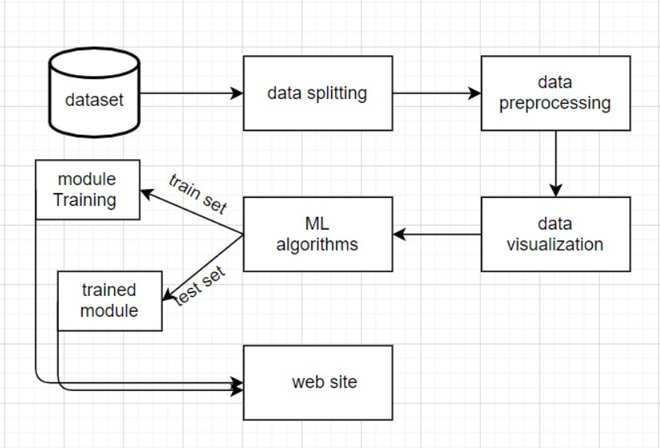

Fig 1.

#### RISK ANALYSIS:

In this project we had faced a problem on connecting the machine learning python code with website. So, we have chosen flask framework which is meant to use for python or python machine learning code. Here python acts as a web server.

1. **INFORMTION OF DATASET:**

The approach is performed on big market sales data of the year 2013. We worked on the dataset from Kaggle. Kaggle, a subsidiary of Google LLC, is an online community of data scientists and machine learning practitioners. We have divided our dataset into two parts: test data, train data. We have first implemented using train data later using test data. There are 11 columns in the dataset and most of them are in object type. There are 11 columns in the dataset and most of them are in object type. There are also few columns with missing data. There are few columns with mixed information i.e there are also 14000 lines of data in this data set.

The image of dataset

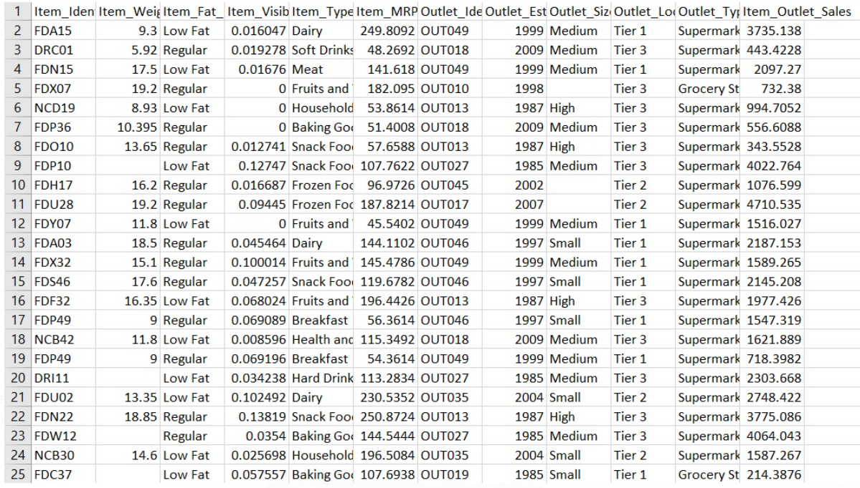

Fig 2.

1. **IMPLEMENTATION:**
   1. **PREPROCESSING DATA:**

Data pre-processing is a process of preparing the raw data and making it suitable for a machine learning model. It is the first and crucial step while creating a machine learning model. When creating a machine learning project, it is not always a case that we come across the clean and formatted data. And while doing any operation with data, it is mandatory to clean it and put in a formatted way. So for this, we use data pre-processing task.

Screenshots of code.

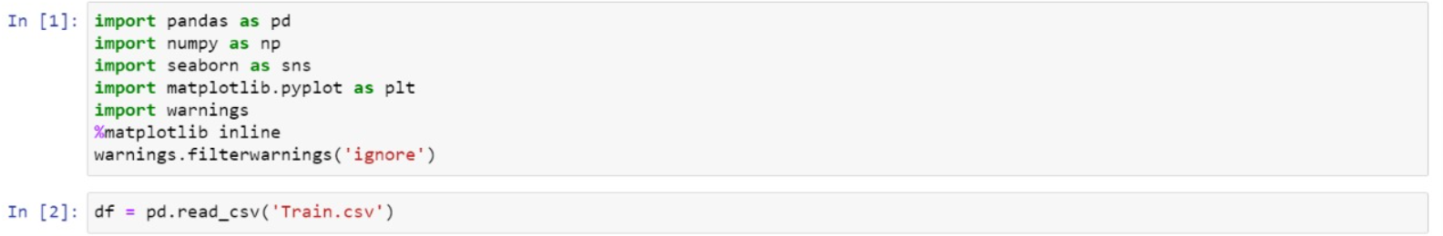

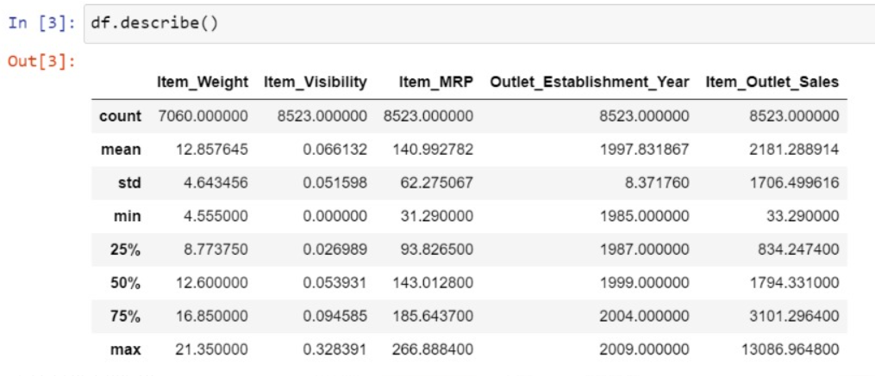

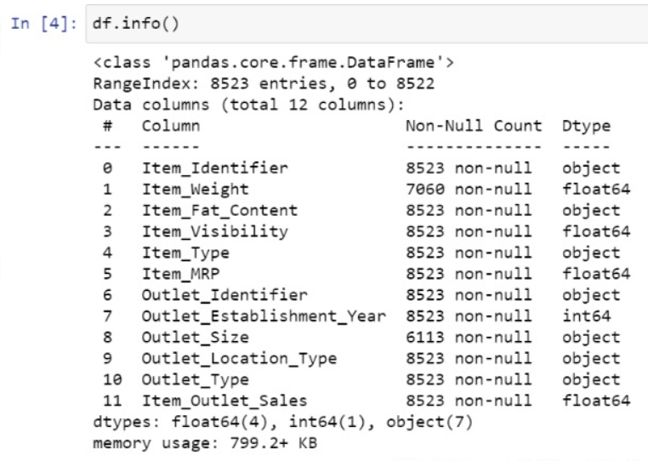

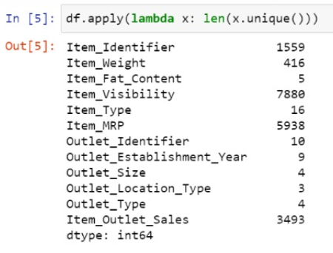

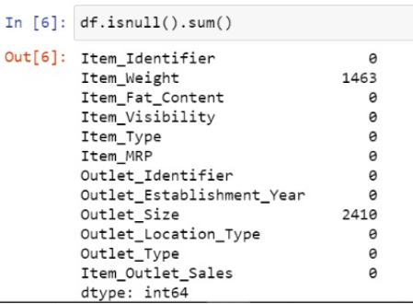

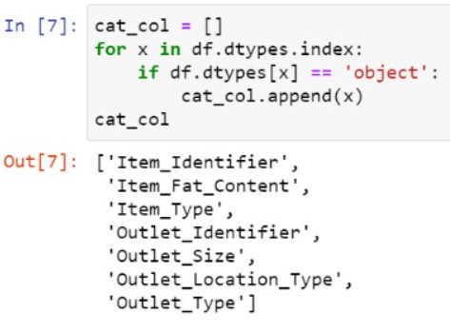

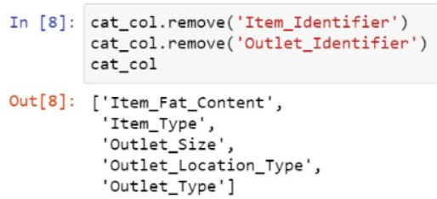

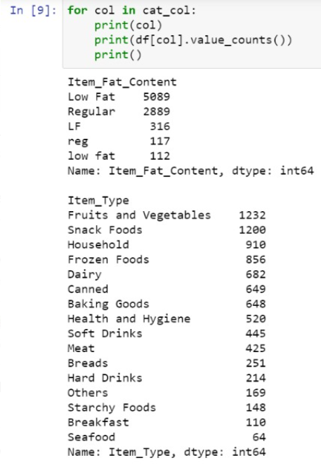

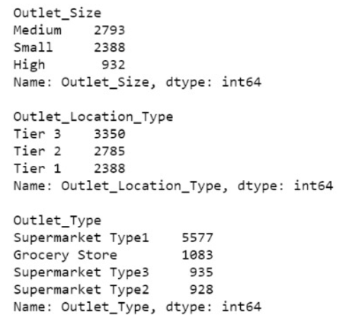

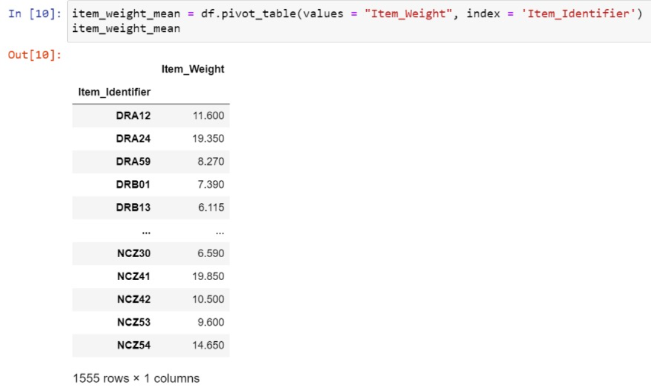

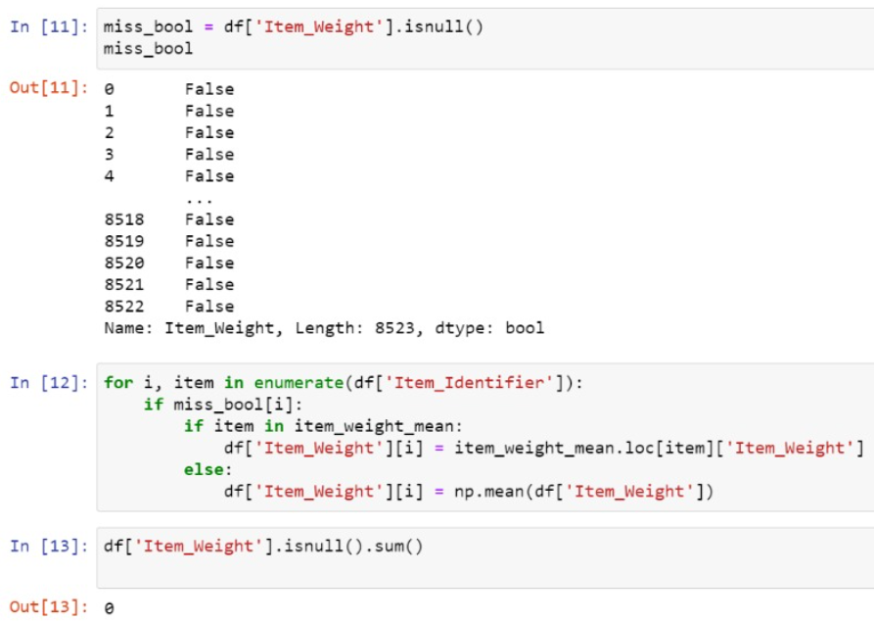

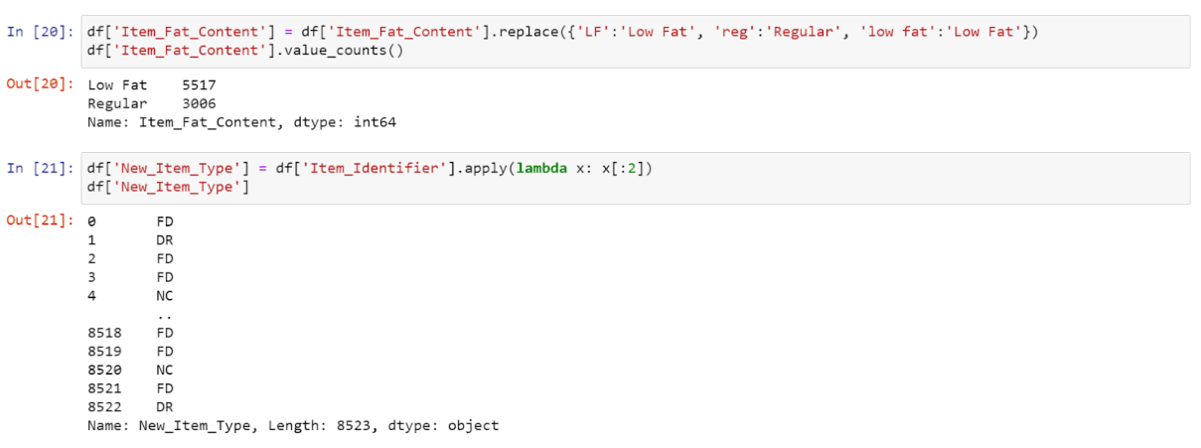

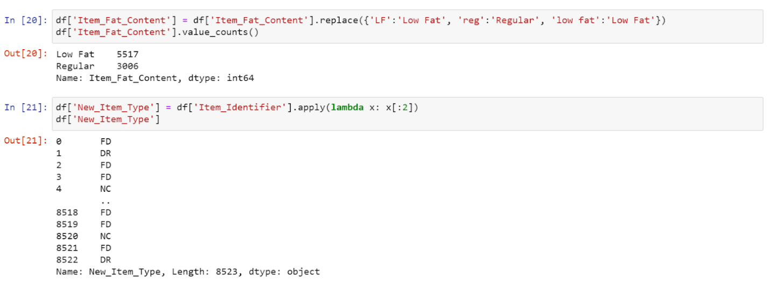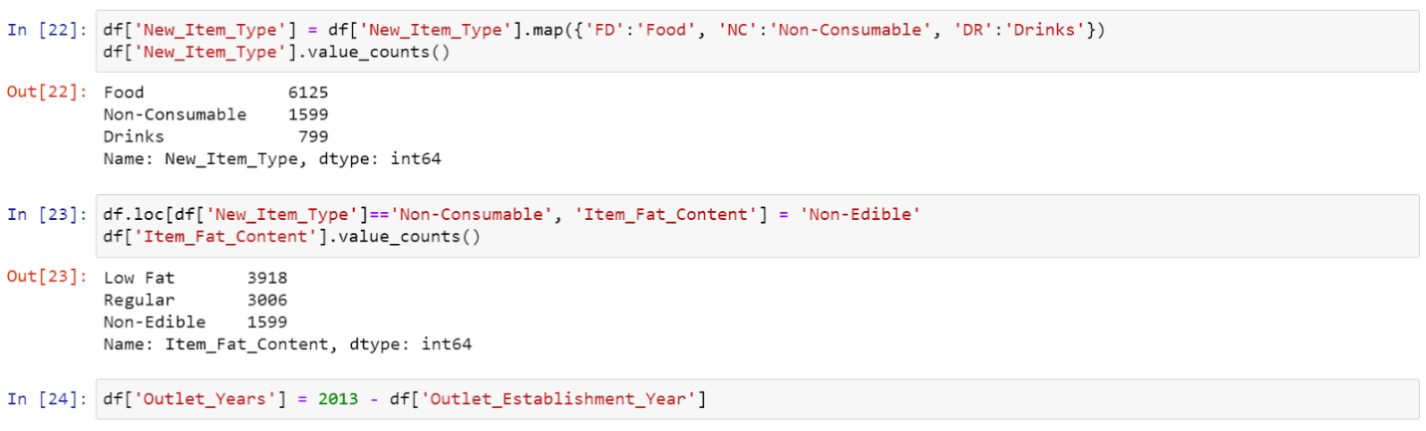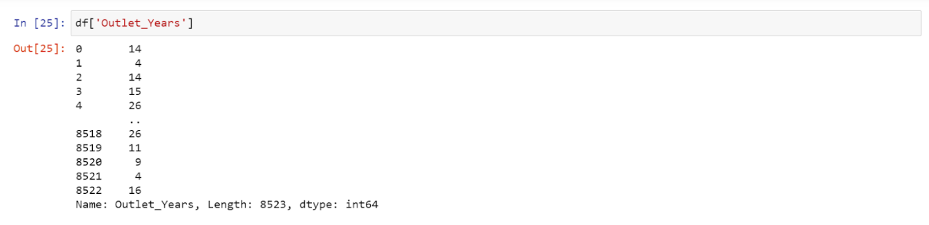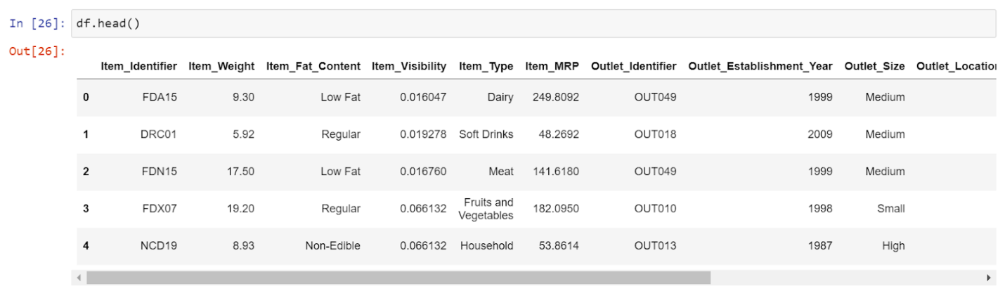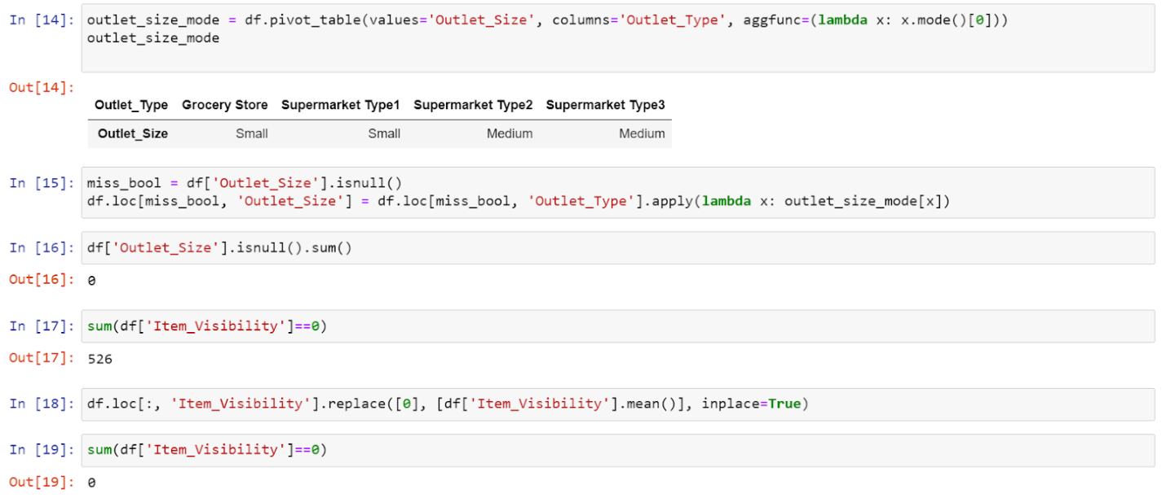

* 1. **DATA VISUALIZATION:**

Data visualization is the representation of data or information in a graph, chart, or other visual format. It communicates relationships of the data with images. This is important because it allows trends and patterns to be more easily seen. With the rise of big data upon us, we need to be able to interpret increasingly larger batches of data. Machine learning makes it easier to conduct analyses such as predictive analysis, which can then serve as helpful visualizations to present. But data visualization is not only important for data scientists and data analysts, it is necessary to understand data visualization in any career.

Data visibility graph

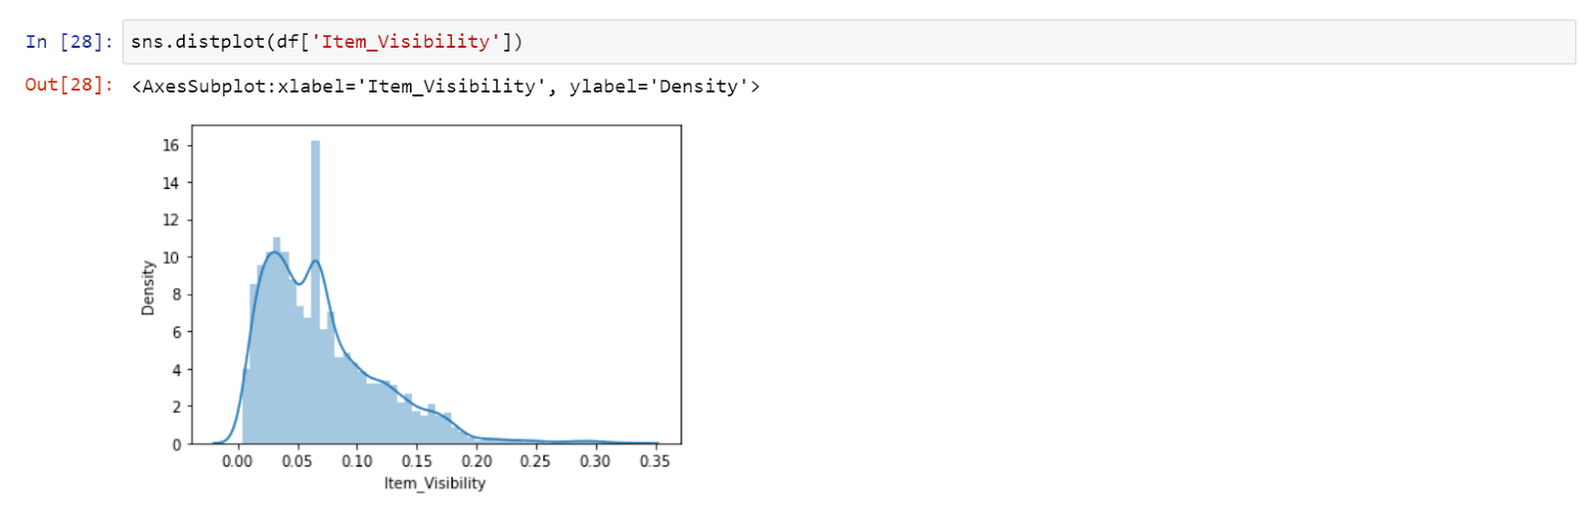

Item MRP graph

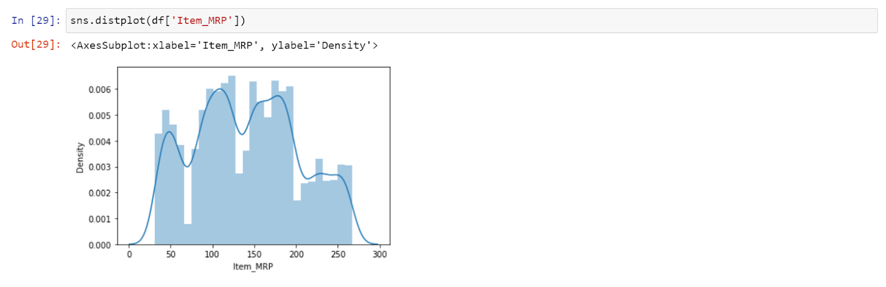

Item outlet sale graph

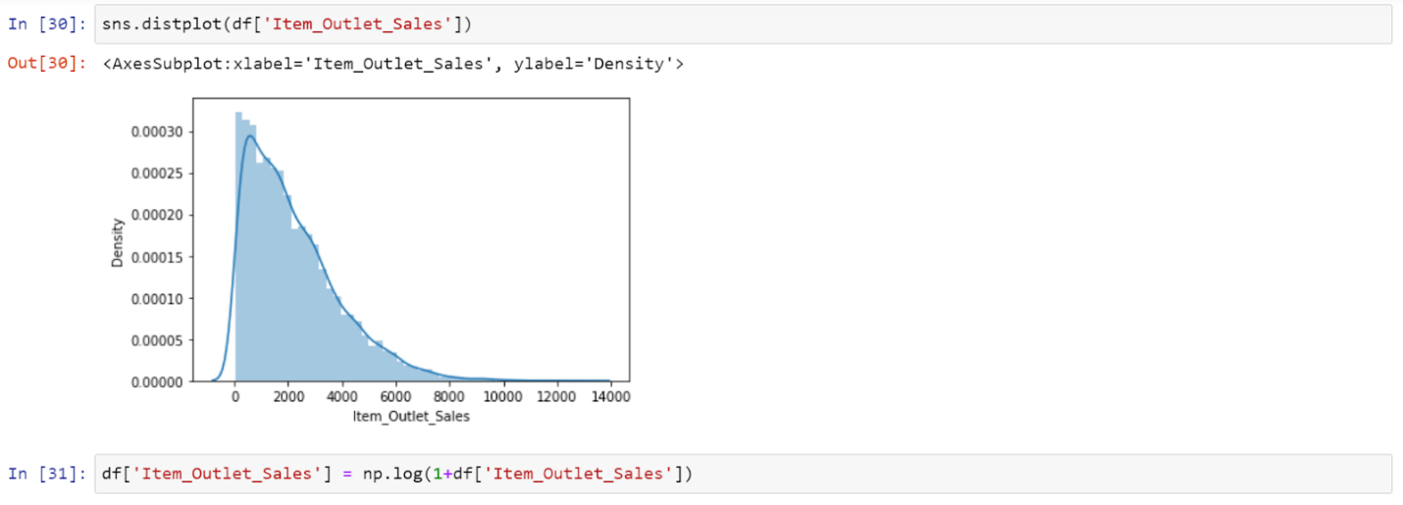

Item outlet sales graph after applying log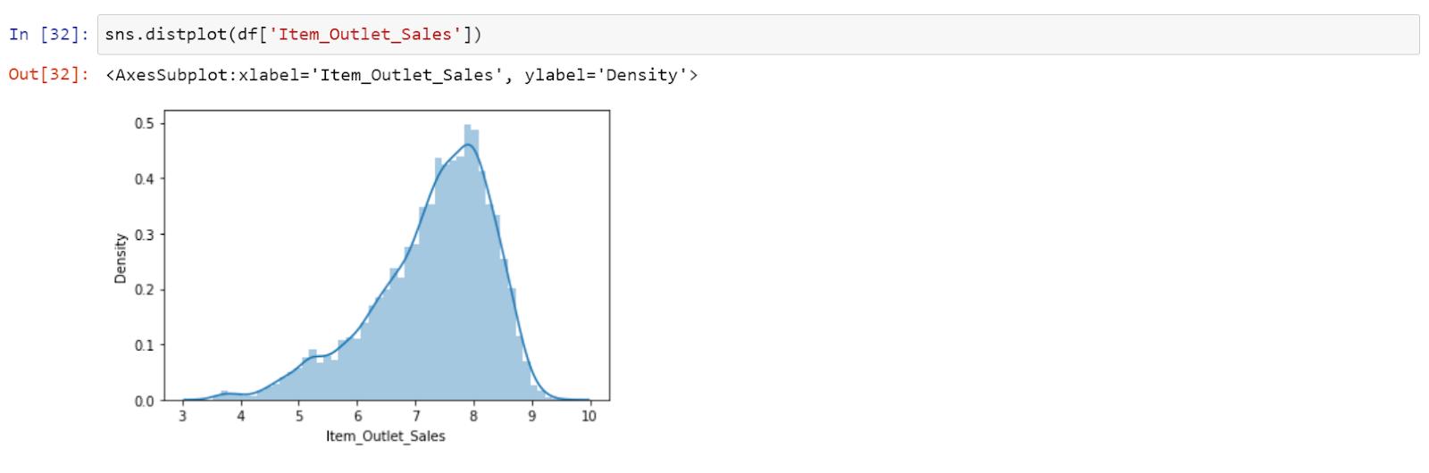

Item fat content bar graph

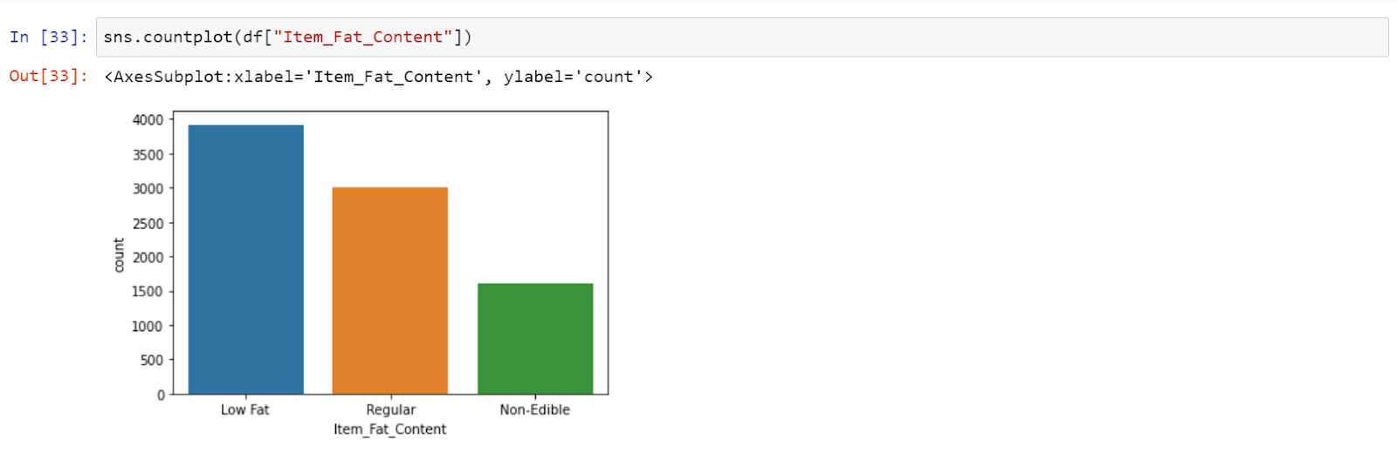

Item type bar graph

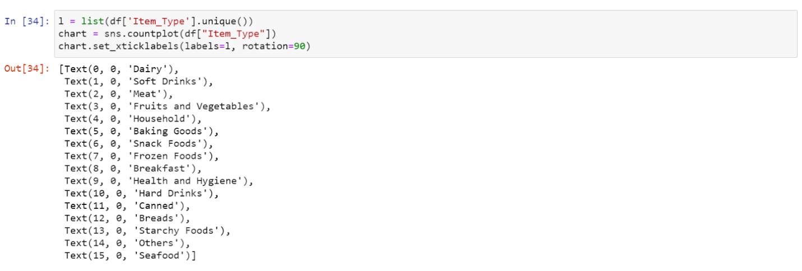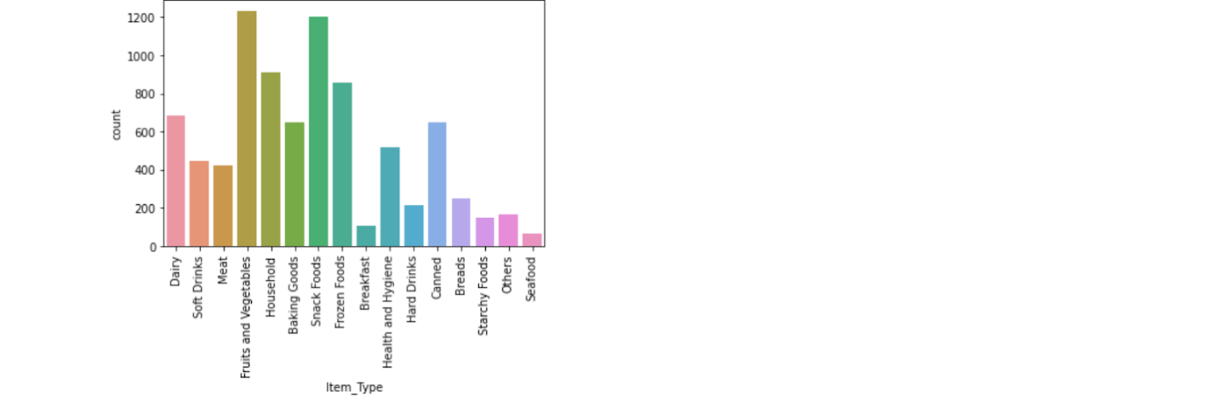

Outlet establishment year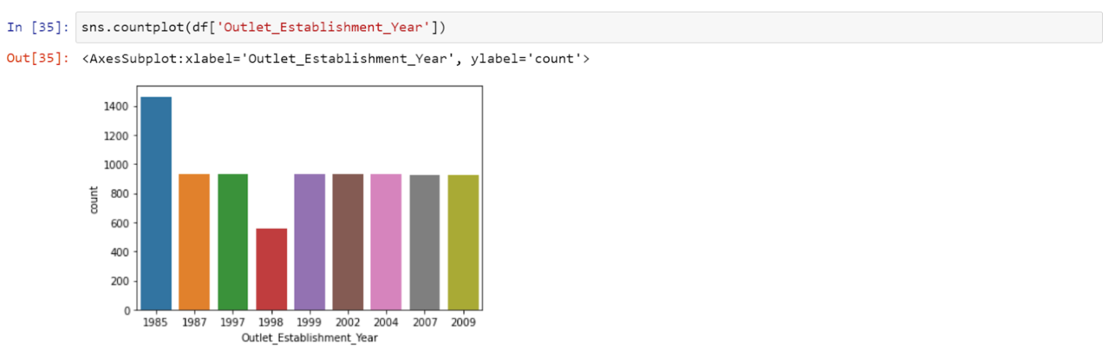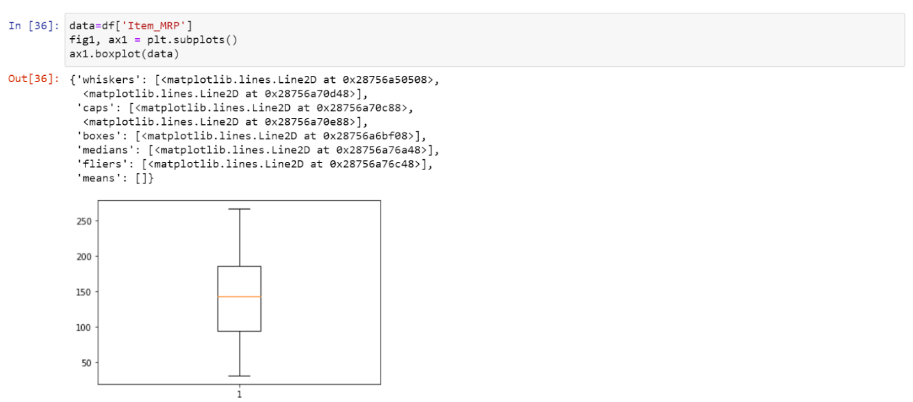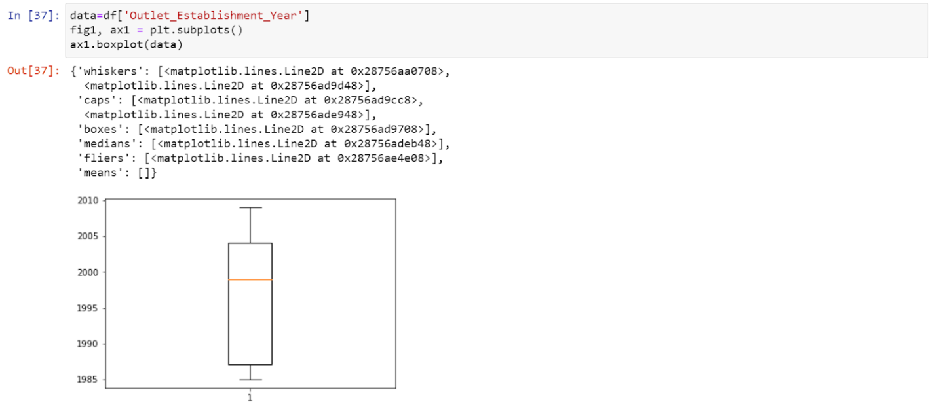

Outlet size bar graph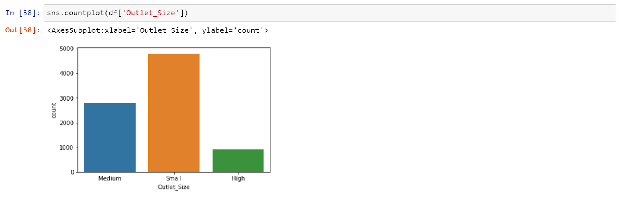

Outlet location type bar graph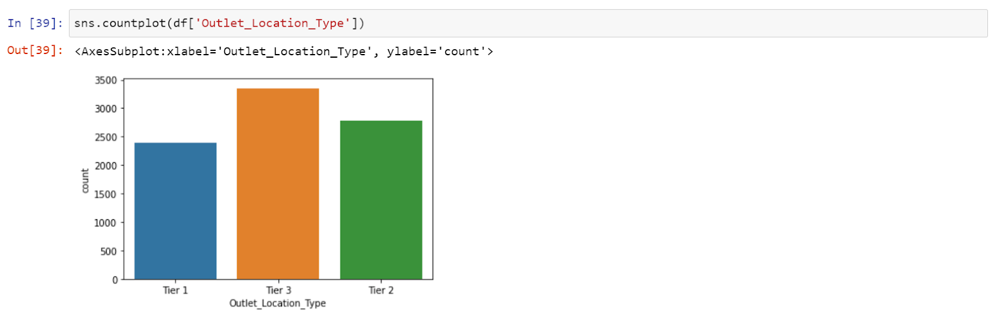

Outlet type bar graph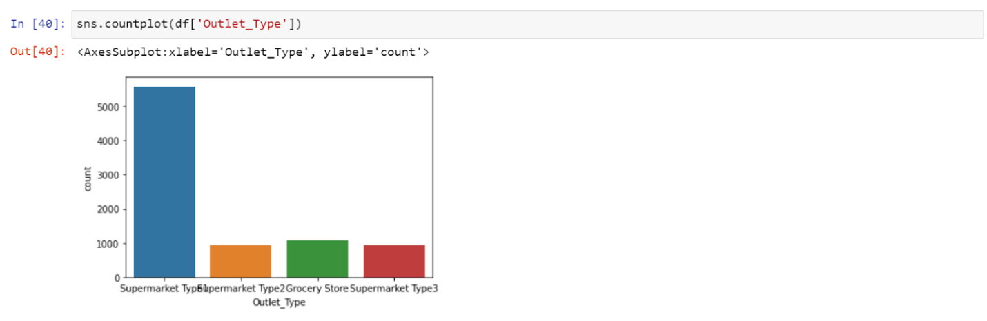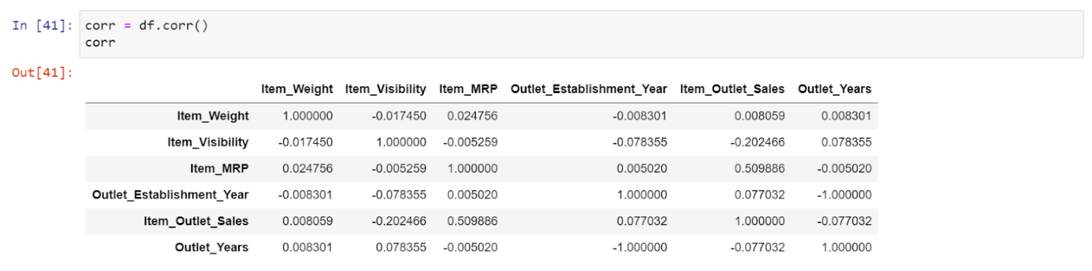

Correlation graphs 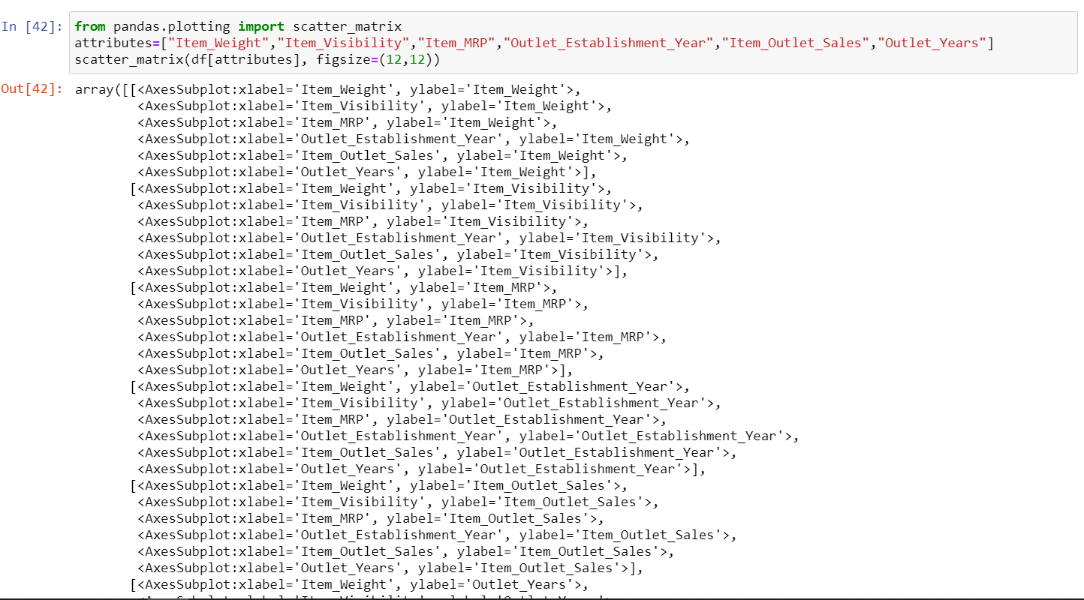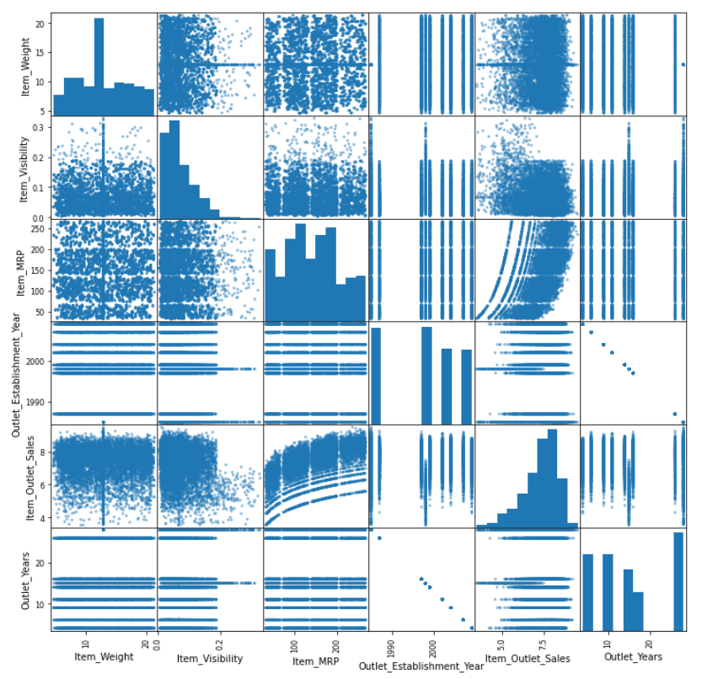

Fig 3

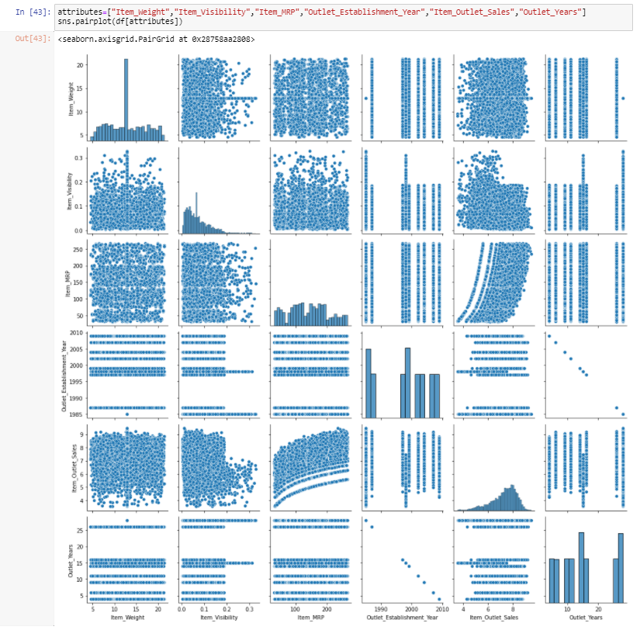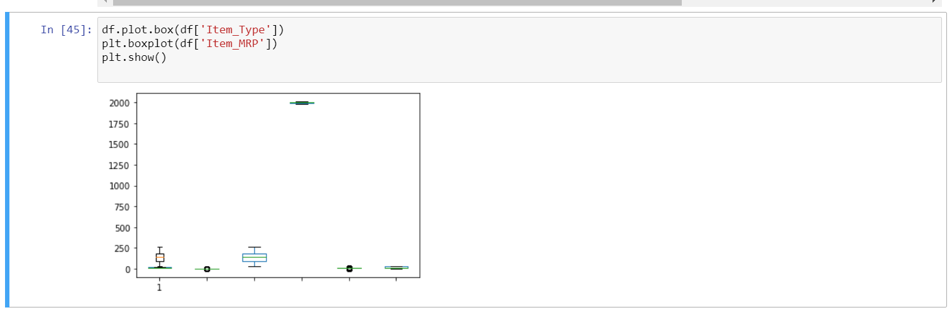

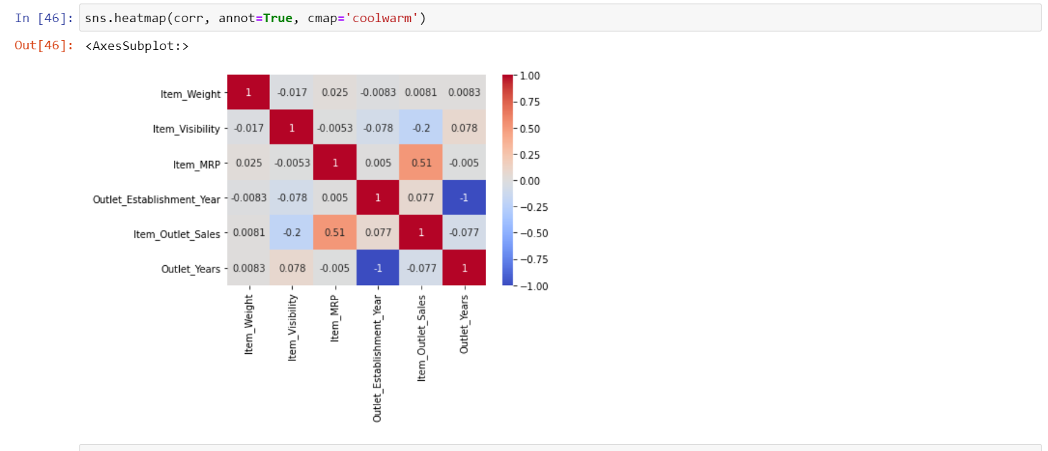

* 1. **DATA ANALYSIS:**

Machine learning is a method of data analysis that automates analytical model building. It is a branch of artificial intelligence based on the idea that systems can learn from data, identify patterns and make decisions with minimal human intervention.

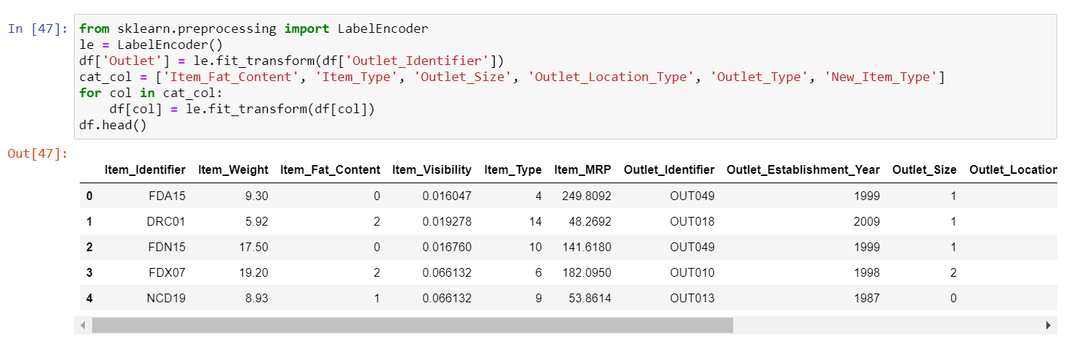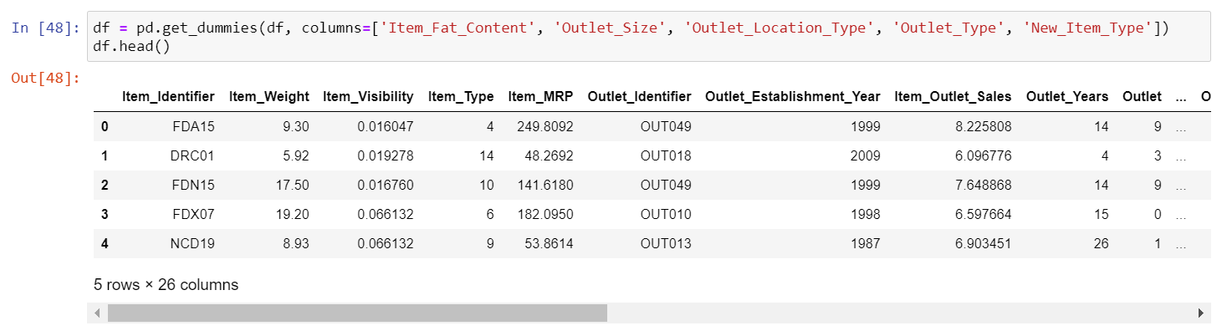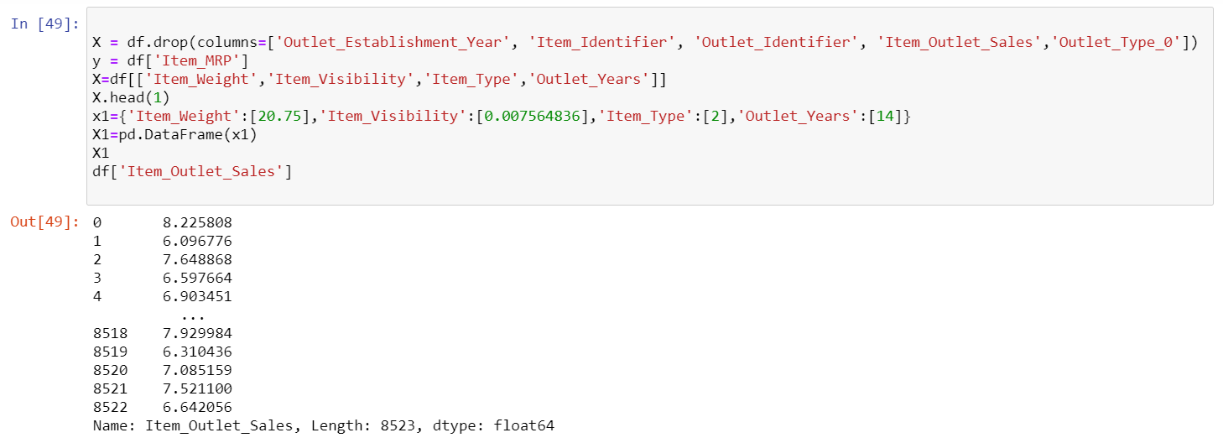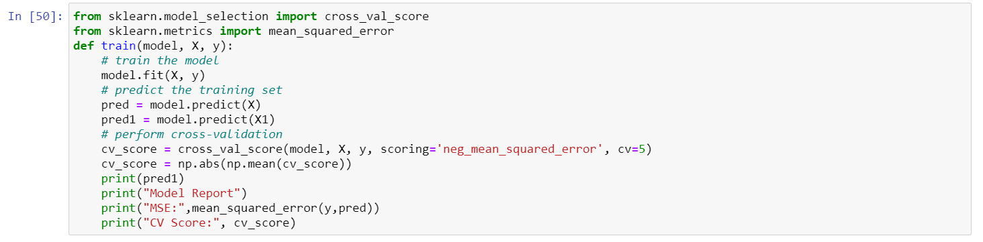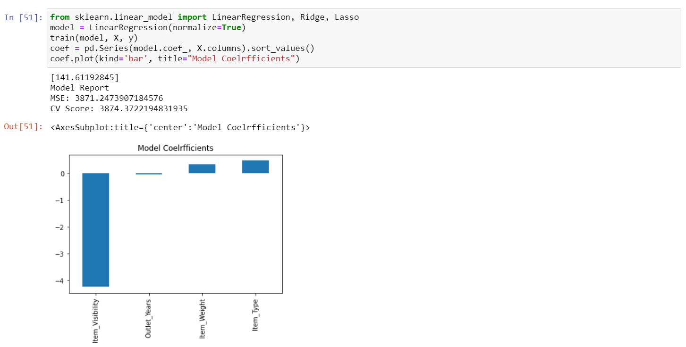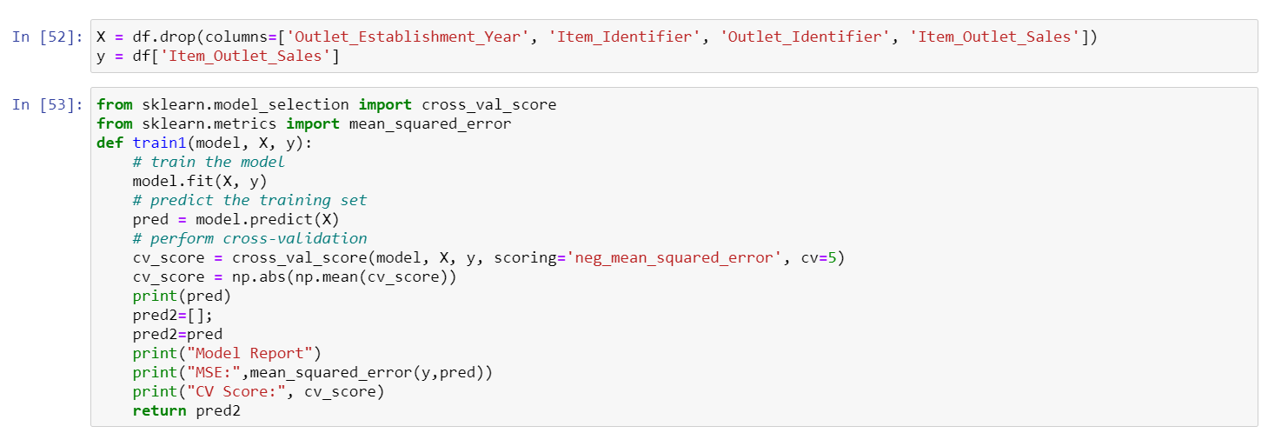

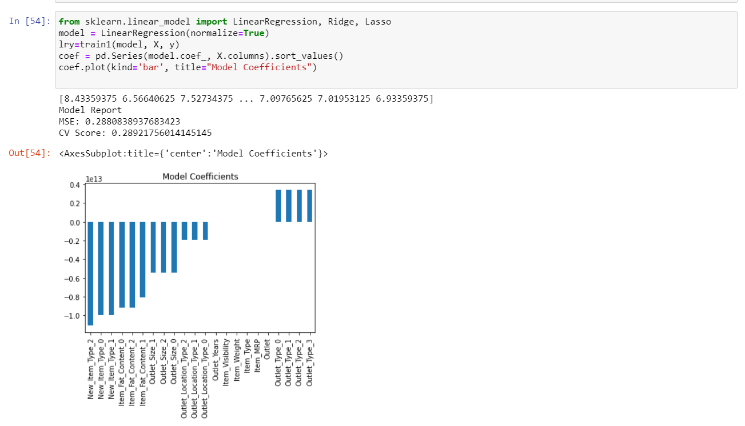

Fig 4

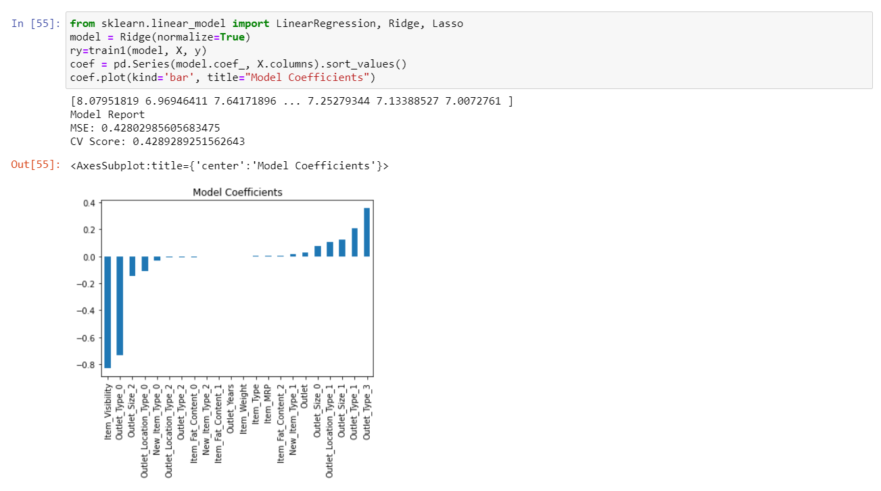

Fig 5

**Lasso:**

Lasso regression is a type of linear regression that uses shrinkage. Shrinkage is where data values are shrunk towards a central point, like the mean. The lasso produce encourages simple, spare models. This particular type of regression is well – suited for models showing height levels of multi collinearity or when you want to automate certain parts of model selection, like variable selection or parameter selection. In lasso algorithm, the Item MRP is high so we can have best predictions for item MRP.

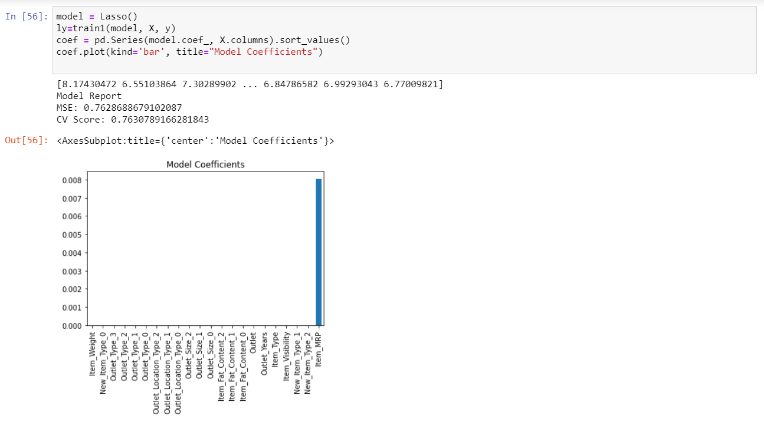fig 6

**Decision Tree:**

Decision tree builds regression or classification models in the form of a tree structure. It breaks down a dataset into smaller and smaller subsets while at the same time an associated decision tree is incrementally developed. The final result is a tree with decision nodes and leaf nodes. A decision node has two or more branches, each representing values for the attribute tested. Leaf node represents a decision on the numerical target. The topmost decision node in a tree which corresponds to the best predictor called root node. Decision trees can handle both categorical and numerical data. In decision tree algorithm outlet-type-0 and item MRP are having good values compared to other columns.

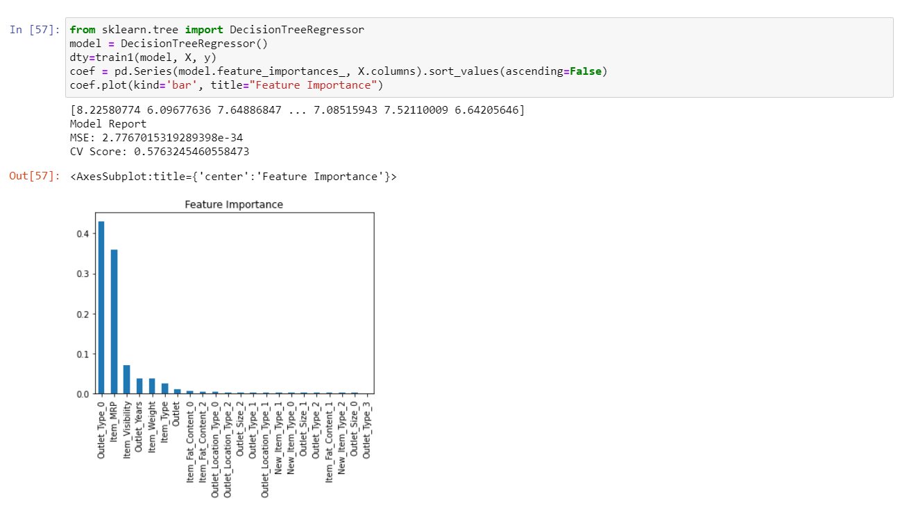

Fig 6

**Random Forest Regression:**

A Random Forest is an ensemble technique capable of performing both regression and classification tasks with the use of multiple decision trees and a technique called Bootstrap Aggregation, commonly known as bagging. What is bagging you may ask? Bagging, in the Random Forest method, involves training each decision tree on a different data sample where sampling is done with replacement. The basic idea behind this is to combine multiple decision trees in determining the final output rather than relying on individual decision trees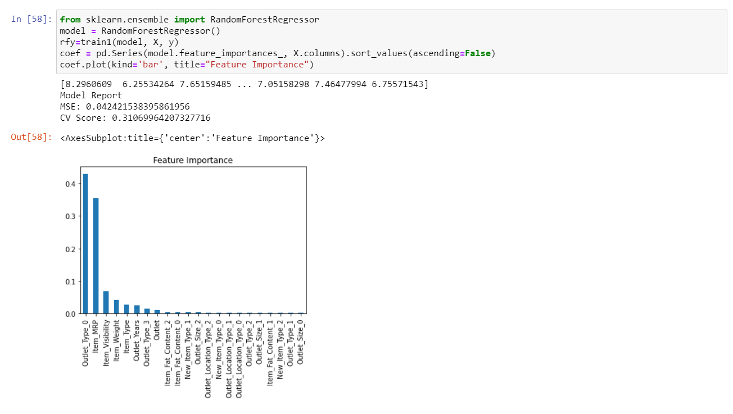

Fig 7

**Extra Tree Regression:**

Extra tree reggressor is a type of ensemble learning technique which aggregate the results of different de-correlated decision trees similar to Random Forest Classifier. Extra Tree can often achieve as good or better performance than the random forest. The key difference is Extra Tree Classifier does not perform bootstrap aggregation like in random forest. In simple words, takes random subset of data without replacement.

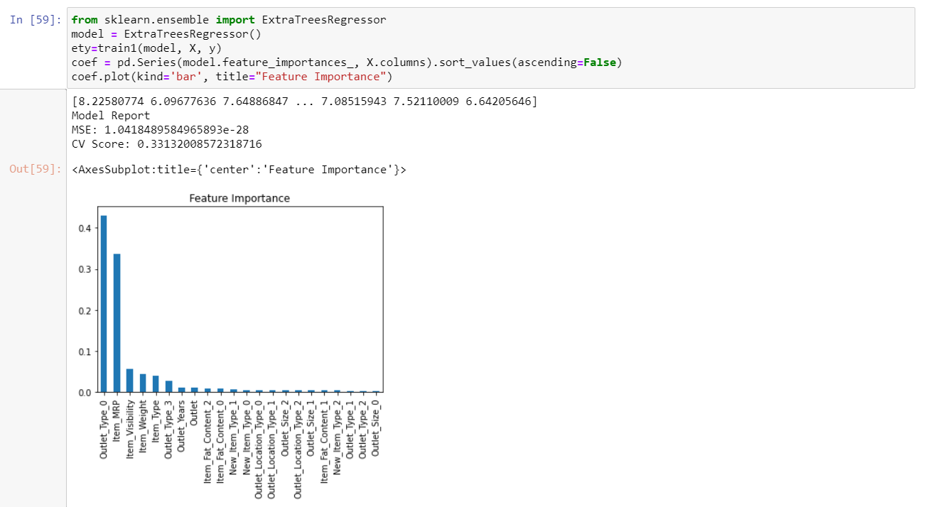

Fig 8

**Support Vector Machine:**

Support Vector Machine or SVM is one of the most popular Supervised Learning algorithms, which is used for Classification as well as Regression problems. However, primarily, it is used for Classification problems in Machine Learning. The goal of the SVM algorithm is to create the best line or decision boundary that can segregate n-dimensional space into classes so that we can easily put the new data point in the correct category in the future. This best decision boundary is called a hyperplane.

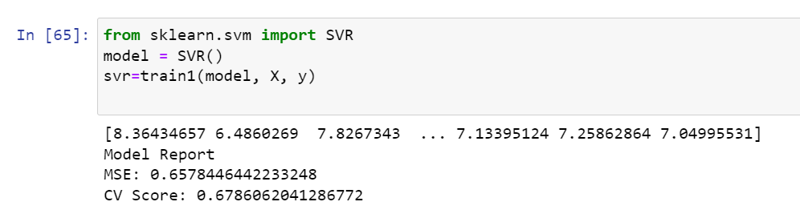

Fig 9

**XGBoost:**

XGBoost is an algorithm that has recently been dominating applied machine learning and Kaggle competitions for structured or tabled data. XGBoost is an implementation of gradient boosted decision tree designed for speed and performance

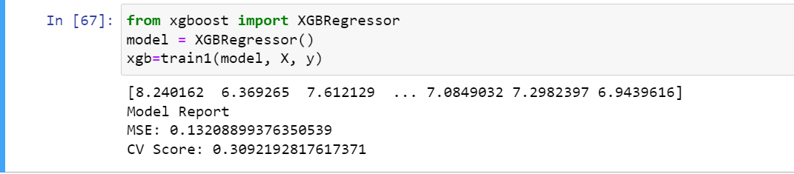

Fig 10

* 1. **COMPARING MODELS:**

The key to a fair comparison of machine learning algorithms is ensuring that each algorithm is evaluated in the same way on the same data. You can achieve this by forcing each algorithm to be evaluated on a consistent test harness.

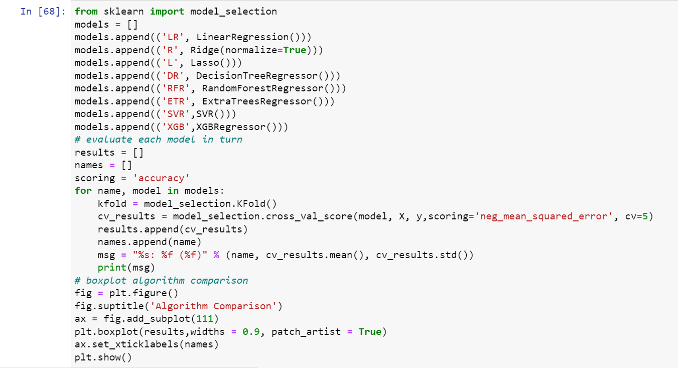

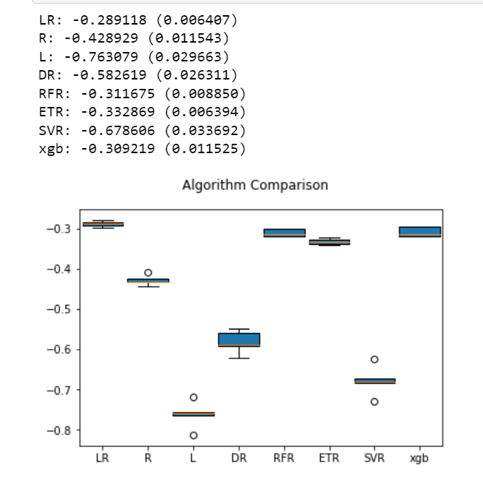

Fig 11

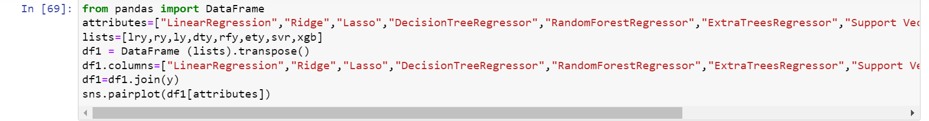

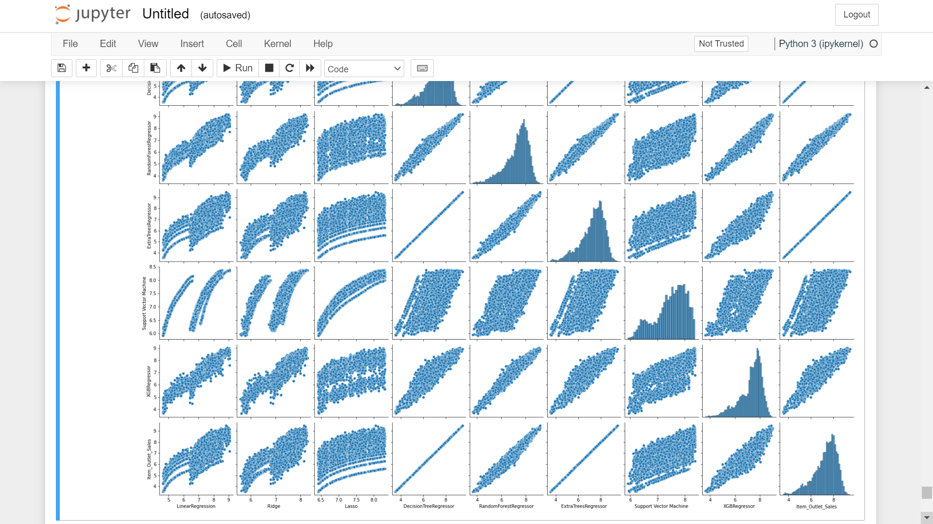Fig 12

**7.5 UI DESIGN:**

The goal of machine learning in user interface design is to create a personalized, comfortable and effective experience

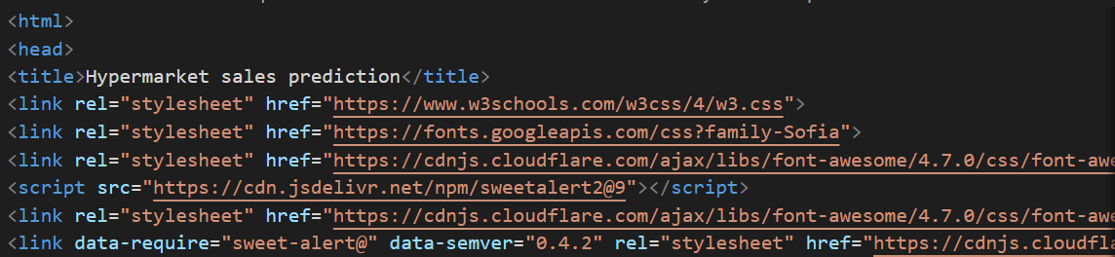

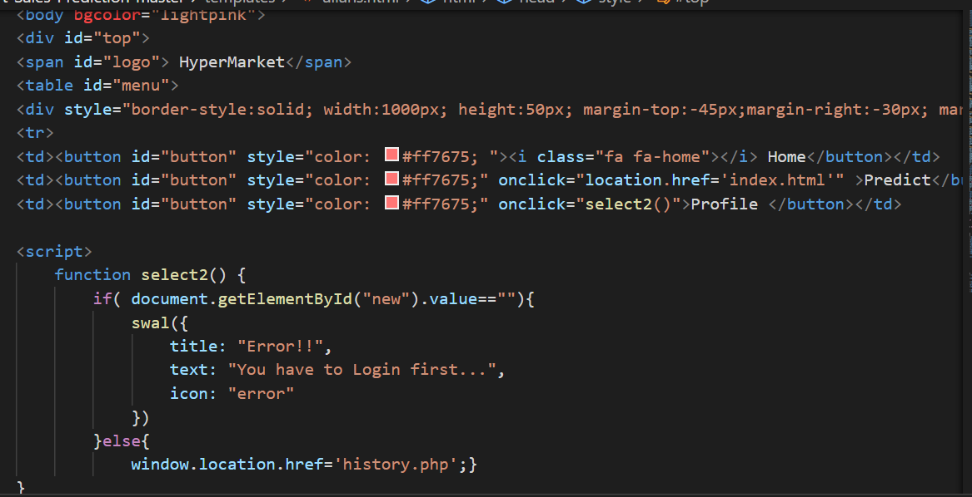

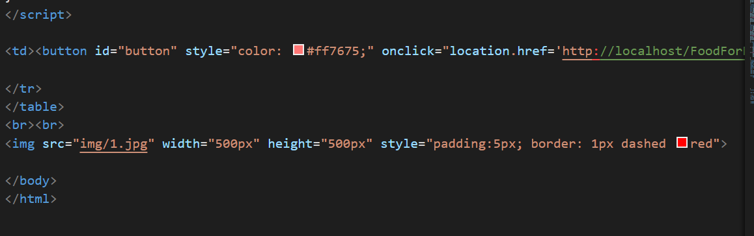

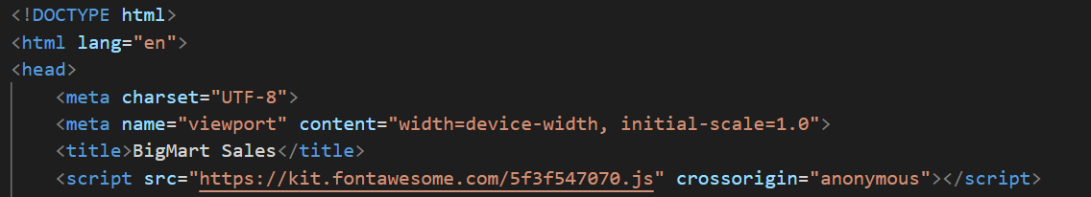

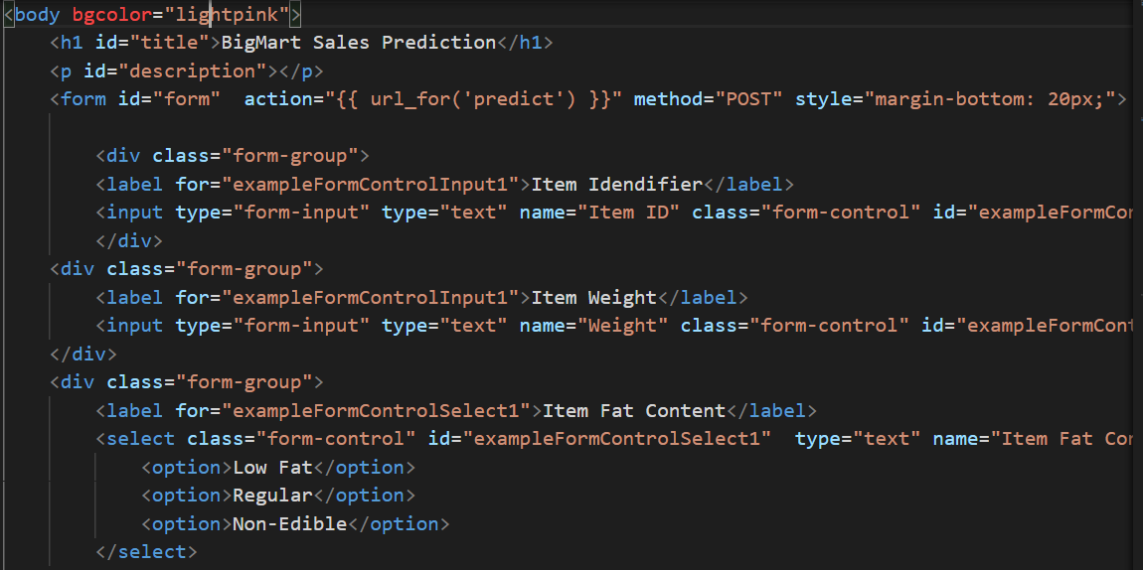

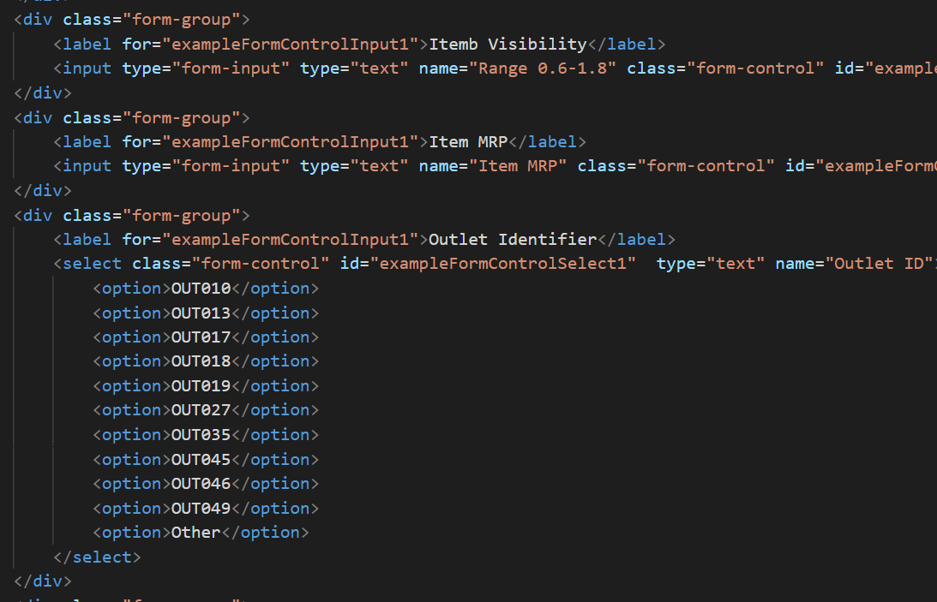

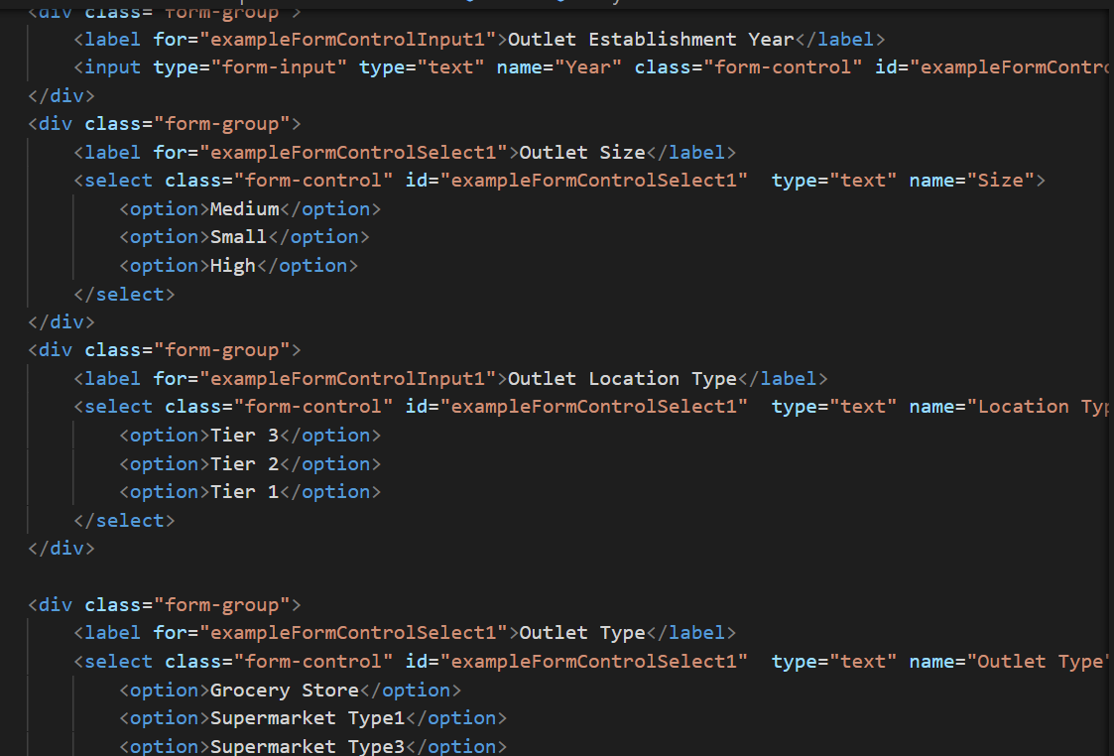

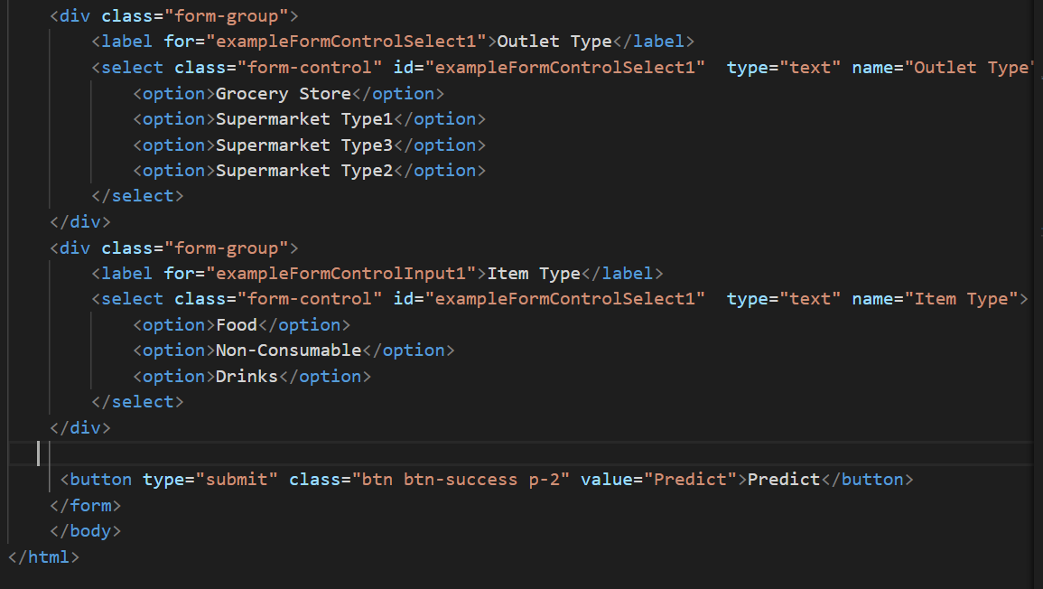

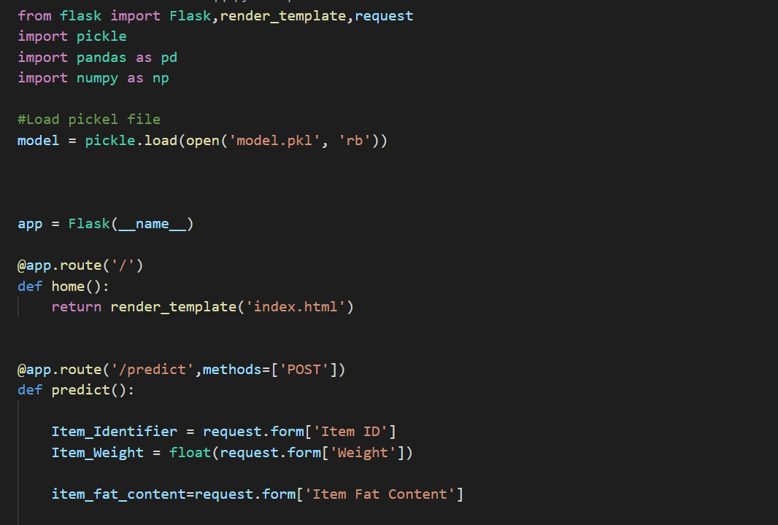

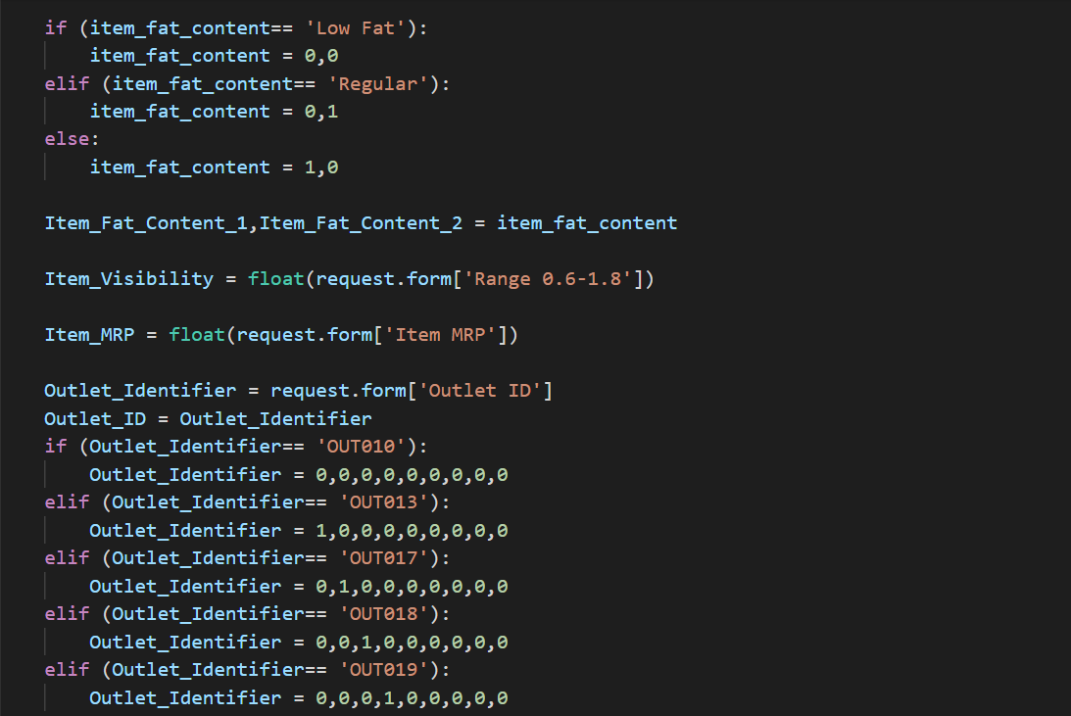

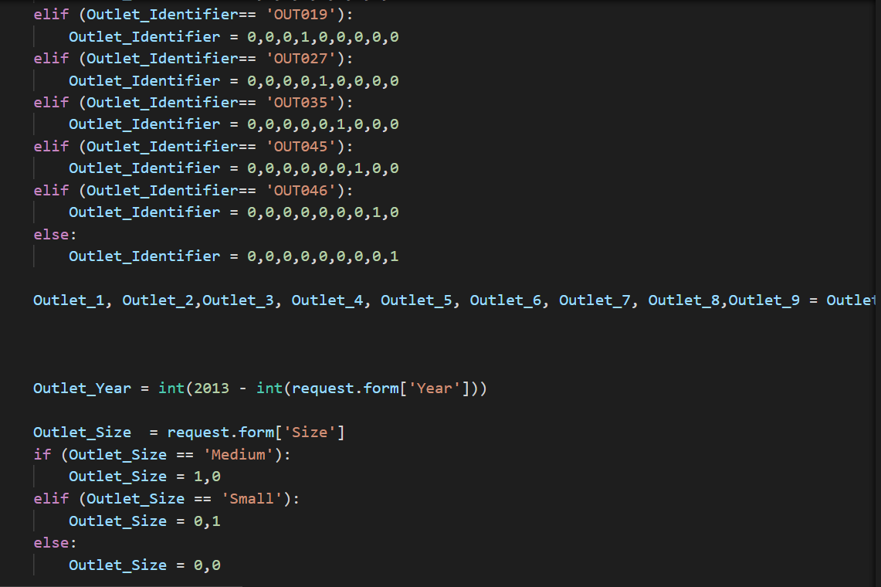

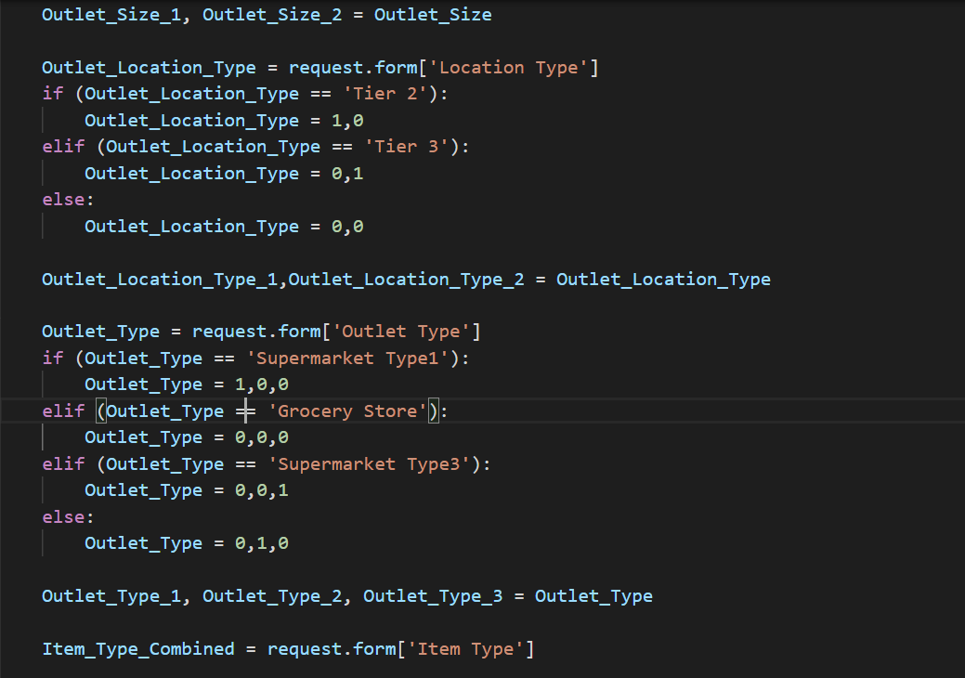

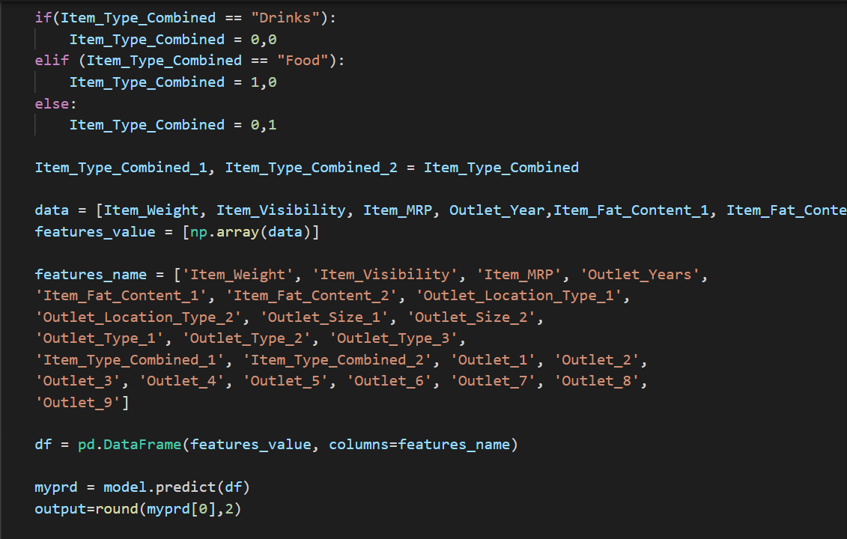

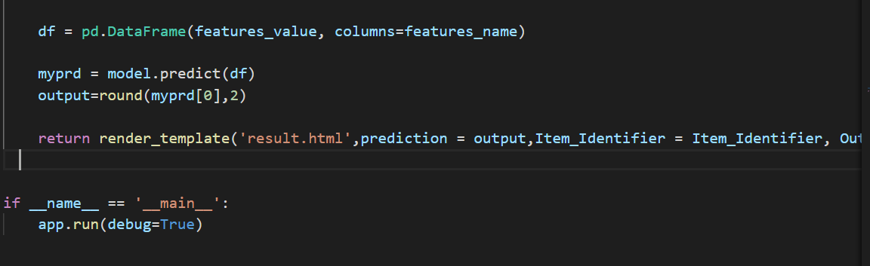



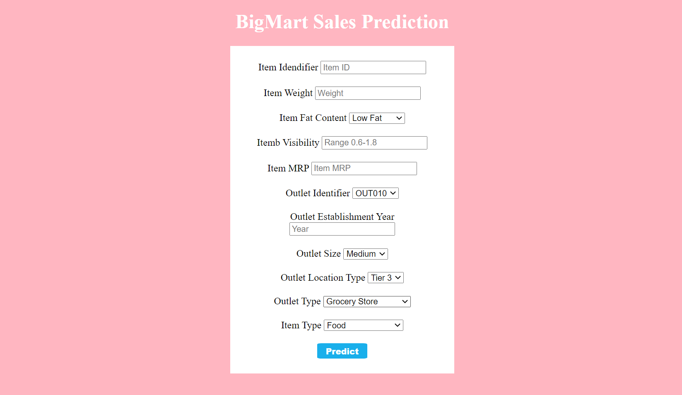

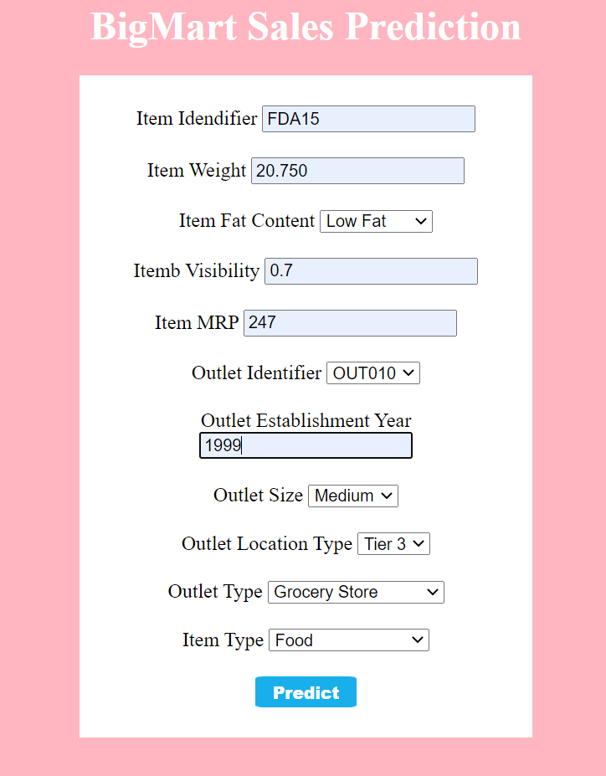



1. **RESULT:**

**The data analysis with the few machine learning modules give good amount of accurate data but not with all the modules and also few algorithms are a time consumable one so there a perfect algorithm of like 86% percentage accurate and which is way fast than the other algorithms.**

**Correlation between decision tree and item outlet sales**

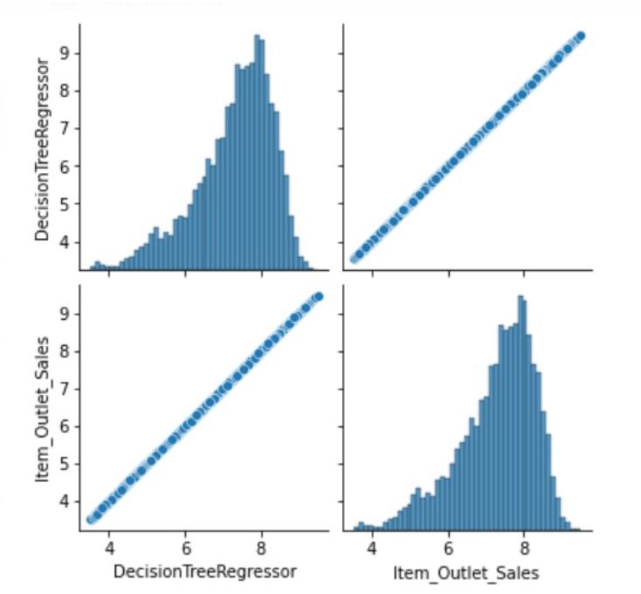

1. **CONCLUSION:**

Our project is work of machine learning and the associated data processing and modelling algorithms have been described, followed by their application for the task of sales prediction in Big Mart shopping malls at different locations. On implementation, the prediction results show the correlation among different attributes considered and how a particular location of medium size recorded the highest sales, suggesting that other shopping locations should follow similar patterns for improved sales. Multiple instances parameters and various factors can be used to make this sales prediction more innovative and successful. Accuracy, which plays a key role in prediction-based systems, can be significantly increased as the number of parameters which had been used increased. When combined with effective data mining methods and properties, the traditional means could be seen to make a higher and positive effect on the overall development of corporation’s tasks on the whole. One of the main highlights are more expressive regression outputs, which is more understandable bounded with some of accuracy. Moreover, the flexibility of the proposed approach can be increased with variants at a very appropriate stage of regression model building.

1. **REFERRENCE:**

[1][https://7t.co/blog/4-ways-machine-learning-influences-ui-design/#:~:text=Using%20Machine%20Learning%20in%20UI,comfortable%20and%20efficient%20user%20experience.](https://7t.co/blog/4-ways-machine-learning-influences-ui-design/%23:~:text=Using%20Machine%20Learning%20in%20UI,comfortable%20and%20efficient%20user%20experience.)

[2][https://ori.hhs.gov/education/products/n_illinois_u/datamanagement/datopic.html#:~:text=Data%20Analysis%20is%20the%20process,and%20recap%2C%20and%20evaluate%20data.&text=An%20essential%20component%20of%20ensuring,appropriate%20analysis%20of%20research%20findings.](https://ori.hhs.gov/education/products/n_illinois_u/datamanagement/datopic.html%23:~:text=Data%20Analysis%20is%20the%20process,and%20recap%2C%20and%20evaluate%20data.&text=An%20essential%20component%20of%20ensuring,appropriate%20analysis%20of%20research%20findings.)

[3] <https://en.wikipedia.org/wiki/Data_virtualization>

[4] <https://www.kaggle.com/datasets>

[5] <https://www.analyticsvidhya.com/blog/2016/02/bigmart-sales-solution-top-20/>

[6] <https://www.xajzkjdx.cn/gallery/423-april2020.pdf>